

Industrial Visit Report

Government Training and Tool Room



October 24, 2024

Government Polytechnic Kadur(197)

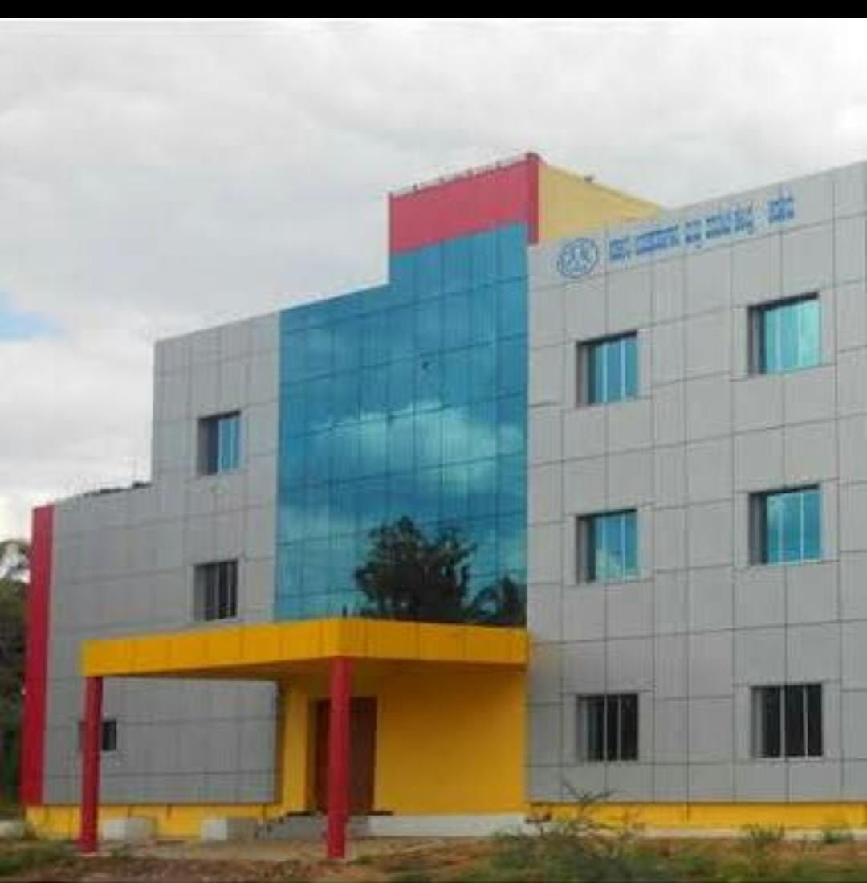

**Industrial Visit Report**

• Title:-Government Training and Tool Room Kadur

• Submitted By:-Spoorthi K P

• Submitted To:-Ramya

• Date of Visit:-24th OCT 2024

• Name of the Student:-Spoorthi K P

• Register Number:-197CS22052

• Branch of Study:-Computer Science

• Institution Name:-Government Polytechnic Kadur

**Contents**

* Introduction
* Overview
* Departments Visited
* Techincal Details
* Conclusion

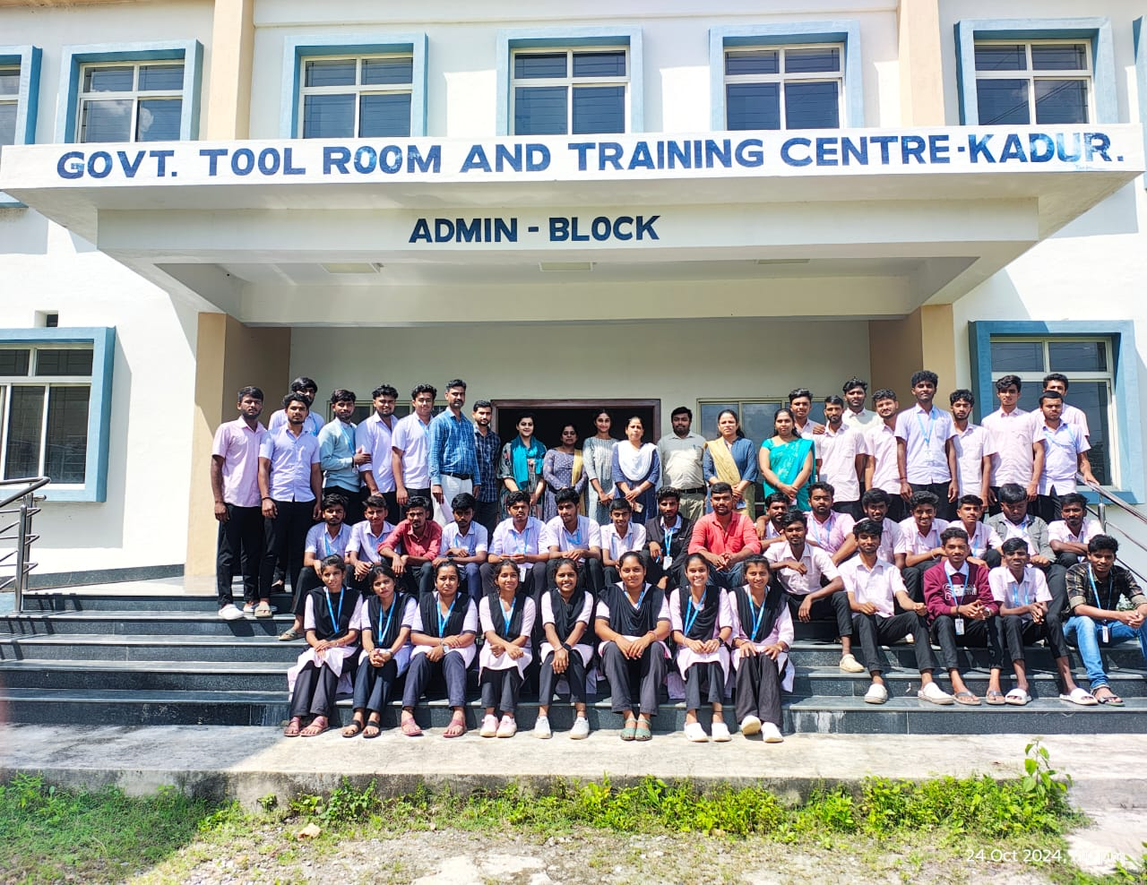

**Introduction**

The Government Training and Tool Room is a diploma college which was located in Kadur near Veda Pump House,NH-206,BH road, Kadur-577548

History:

 GTTC established its sub centre at Kadur vides Govt. order: YK 28 RAV.2006 Dated: 07.12.2006 in the Sericulture Dep. Building in the Year 2007. Then moved to its own building in 2015 constructed to the adjacent side, in 4 Acres Land allotted by Kadur Municipality

**Overview**

GTT College of Education (GTTC Kadur) is a prominent teacher training institution located in Kadur, Karnataka, dedicated to nurturing future educators through its various programs, primarily the Bachelor of Education (B.Ed). The college is affiliated with a recognized university and complies with the standards set by the National Council for Teacher Education (NCTE), ensuring a quality education that meets national requirements.

The curriculum is thoughtfully designed to integrate both theoretical and practical aspects of teaching, offering students a well-rounded understanding of pedagogy, educational psychology, and curriculum development. The college provides modern infrastructure, including spacious classrooms, a well-stocked library, and advanced training facilities, fostering an environment conducive to learning and professional growth.

In addition to academic excellence, GTTC Kadur places a strong emphasis on community involvement, encouraging students to engage in outreach programs that enhance their social awareness and responsibility. This holistic approach prepares graduates not only for successful careers in teaching but also as active contributors to society.

Moreover, the college offers robust placement support, helping students navigate the job market and secure teaching positions in various educational institutions. With a commitment to producing competent and compassionate educators, GTTC Kadur stands out as a leading choice for those aspiring to make a difference in the field of education.  **Departments**

When visiting the Governmnet Training and Tool room we cam see key departments and areas of interest, which may include:-

The Government Training and Tool Room in Kadur features various specialized labs to enhance practical training in technical fields. Key facilities typically include a Machining Lab for hands-on experience with lathes and CNC machines, a Welding Lab for mastering different welding techniques, and a Fabrication Lab focused on metalworking processes. Additionally, there’s an Electronics Lab for circuit design, a Computer Lab equipped with design software like CAD, and a Tool Design Lab dedicated to developing tools and fixtures for manufacturing. These labs collectively aim to equip trainees with essential skills for the industry.

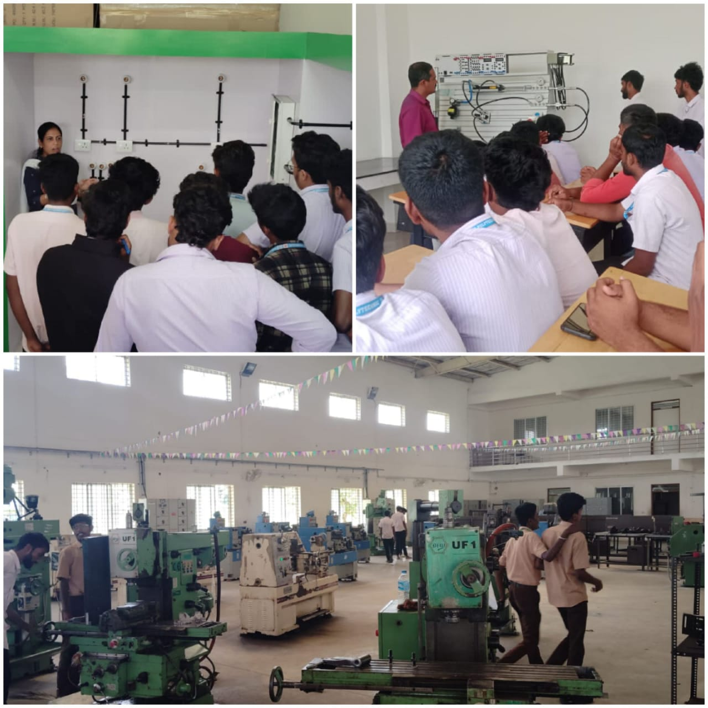

**Technical Details**

GTT College of Education (GTTC Kadur) boasts a range of specialized workshops and laboratories designed to enhance the practical learning experience for aspiring educators. The college regularly conducts workshops focused on innovative teaching methodologies, educational technology, and skill development, allowing students to engage actively with modern teaching practices. Its facilities include a Psychology Lab, which is equipped for psychological assessments and experiments, helping students understand learner behavior. The Language Lab features audio-visual aids and software to facilitate language acquisition and improve communication skills. Additionally, dedicated Science Laboratories for physics, chemistry, and biology provide hands-on opportunities for conducting experiments, while a Computer Lab offers access to educational software, enhancing digital literacy. The Art and Craft Studio serves as a creative space for exploring artistic methods, enabling students to incorporate art education into their teaching. Collectively, these workshops and labs play a crucial role in providing students with the practical skills and knowledge necessary for effective teaching, contributing to a comprehensive educational experience.

**Conclusion**

**In conclusion, GTT College of Education (GTTC Kadur) stands out as a vital institution in the realm of teacher training, equipped with a diverse range of departments and specialized laboratories that cater to the comprehensive development of future educators. By integrating theoretical knowledge with practical experience across various subjects, the college prepares its students to meet the challenges of modern education effectively. The focus on community engagement and holistic learning further enhances the educational experience, fostering a sense of responsibility and commitment to societal development. With strong placement support and a nurturing environment, GTTC Kadur not only cultivates skilled educators but also inspires them to make meaningful contributions to the field of education and beyond.**